Computer Graphics:

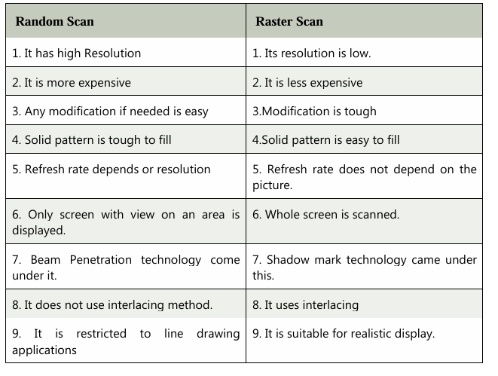

Sure! Here's the expanded tabular comparison between Virtual Reality (VR) and Augmented Reality (AR):
Aspect | Virtual Reality (VR) | Augmented Reality (AR)
Definition | Fully immersive digital environment | Digital content overlaid on the real world
Immersion Level | High (complete immersion) | Medium (partial immersion)
View of Real World | Completely blocked or replaced | Real world is visible with digital additions
Hardware | VR headset, controllers, motion sensors | Smartphone, tablet, AR glasses
Mobility | Limited; often requires a set space | High; can be used on-the-go
Interaction | With the virtual environment only | With both real and virtual elements
Use Cases | Gaming, simulations, training, therapy, virtual tourism | Navigation, gaming (e.g., Pokémon Go), industrial, retail, education
Reality Base | Entirely artificial | Real world enhanced with virtual content
Internet Required | Sometimes (depends on app) | Often required for live data and overlays
Cost | Often more expensive (due to specialized hardware) | More accessible (runs on common devices)
Examples | Oculus Quest, HTC Vive, PlayStation VR | Snapchat filters, IKEA Place app, Google Lens
Learning & Training | Used in simulations like flight, surgery, or virtual classrooms | Used in medical training, machinery repair, classroom enhancements
Gaming Experience | Fully immersive 3D gaming world | Real-world gaming with virtual elements

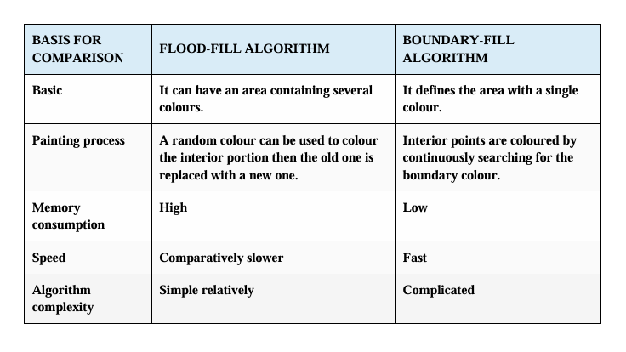

Here’s a clear tabular difference between viewport and window in the context of computer graphics:
Aspect | Window (World Coordinate System) | Viewport (Device Coordinate System)
Definition | The region in the world coordinate system that you want to display | The region on the display device (screen) where the image is shown
Coordinate System | World coordinates (logical coordinates) | Device coordinates (pixel-based, screen coordinates)
Purpose | Defines what part of the scene is selected for display | Defines where the selected part appears on the screen
Units | Logical or user-defined units (e.g., meters, inches) | Pixels or screen units
Transformations | Maps world coordinates to normalized coordinates | Maps normalized coordinates to screen coordinates
User Control | Determines the portion of the scene to be viewed | Determines the size and position of the view on the screen
Analogy | A camera's viewfinder (decides what you see) | The TV screen (shows what the camera captured)
Aspect Ratio | Should match the viewport's aspect ratio to avoid distortion | Should match the window’s aspect ratio for accurate display
Example | Window: (xmin=0, xmax=100, ymin=0, ymax=100) | Viewport: (x=200, y=300, width=400, height=400)

Linux Operating System
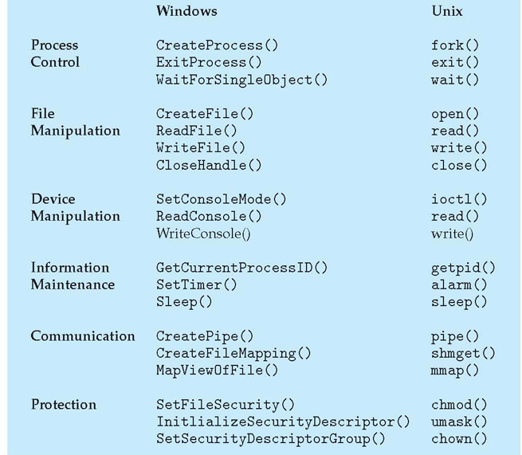

Here's a tabular comparison between grep, egrep, and fgrep in Linux/Unix:
Command | Full Form | Description | Supports Regular Expressions? | Special Features
grep | Global Regular Expression Print | Searches text using basic regular expressions (BRE) | Yes (basic regex) | Most commonly used; can be slower for complex patterns
egrep | Extended Global Regular Expression Print | Searches using extended regular expressions (ERE) (e.g., +, ` | , ?`) | Yes (extended regex)
fgrep | Fixed Global Regular Expression Print | Searches for fixed strings, no regex interpretation | No | Fastest for plain string search; same as grep -F

Emerging Trends in Computer Engineering
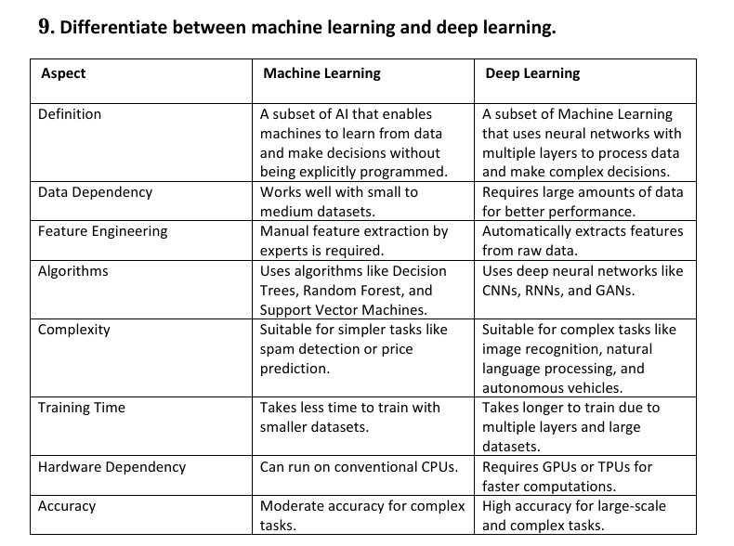
Here's a clear tabular comparison between Supervised Machine Learning and Unsupervised Machine Learning:
Aspect | Supervised Machine Learning | Unsupervised Machine Learning
Definition | The model learns from labeled data | The model learns from unlabeled data
Training Data | Input data includes both input features and correct output | Input data has only input features, no labeled output
Goal | Predict outcomes for new data | Discover hidden patterns or structure in data
Examples | Classification, Regression | Clustering, Association
Output Type | Predicts labels or continuous values | Groups similar data points or finds relationships
Data Requirement | Needs a large amount of labeled data | Works with data that doesn't need labeling
Algorithm Examples | Linear Regression, Decision Trees, SVM, KNN, Neural Networks | K-Means, Hierarchical Clustering, PCA, Apriori
Accuracy | Generally higher (when enough labeled data is available) | Can be lower or exploratory, depending on patterns discovered
Complexity | Easier to evaluate and validate | Harder to interpret results and measure accuracy
Use Cases | Email spam detection, disease prediction, stock price forecasting | Customer segmentation, market basket analysis, anomaly detection

Here’s a tabular comparison between a program with AI and a program without AI:
Aspect | Program with AI | Program without AI
Definition | A program that mimics human intelligence to make decisions, learn, or adapt | A traditional program that follows fixed, predefined instructions
Behavior | Dynamic and adaptive behavior; can improve over time | Static behavior; does exactly what it is coded to do
Learning Capability | Learns from data and past experiences (e.g., machine learning) | No learning ability; logic is hard-coded
Flexibility | Can handle complex, unpredictable situations | Works well only for well-defined and specific tasks
Examples | Chatbots, recommendation systems, self-driving cars, speech recognition | Calculator, file copier, attendance management system
Data Usage | Uses large datasets to make predictions or decisions | Uses data only as input/output
Decision Making | Makes decisions based on patterns, probabilities, or models | Makes decisions using fixed if-else or switch-case logic
Human-Like Thinking | Simulates human reasoning, perception, or understanding | No human-like thinking
Code Complexity | Usually more complex (involves models, algorithms, training) | Simpler and easier to debug
Adaptability | Can improve performance with more data or feedback | Performance stays the same unless manually updated

🧠

Here's a tabular comparison between a General Purpose Computing System and an Embedded System:
Aspect | General Purpose Computing System | Embedded System
Definition | A computer designed to perform a wide variety of tasks | A computer system designed to perform a specific, dedicated task
Functionality | Multi-functional, can run different software programs | Task-specific, optimized for one or a few functions
Examples | Desktop PCs, laptops, smartphones | Washing machine controller, ATM, microwave oven, smartwatches
User Interaction | Typically involves direct user interaction | May or may not involve user interaction
Operating System | Uses general-purpose OS (e.g., Windows, Linux, macOS) | May use real-time or lightweight OS (e.g., RTOS, FreeRTOS)
Flexibility | Highly flexible; user can install/uninstall apps | Limited flexibility; functionality is usually fixed
Performance Optimization | Not always optimized for a specific task | Optimized for performance, power, and size for a specific job
Resource Constraints | Generally has ample CPU, memory, and storage resources | Limited CPU, memory, and power resources
Cost | Higher cost due to versatility and hardware | Lower cost, as only required components are used
Upgradability | Hardware and software can be upgraded easily | Usually not upgradeable; comes as a fixed package
Power Consumption | Higher power usage | Power-efficient (important for battery-powered systems)
Programming | Can be reprogrammed for different applications | Programmed once for a specific application

🧠

Aspect | Von Neumann Architecture | Harvard Architecture
Definition | A computer architecture where program and data share the same memory | A computer architecture where program and data have separate memory
Memory Structure | Single memory for both instructions and data | Separate memory for instructions and data
Bus System | Single bus for both data and instructions | Separate buses for data and instructions
Speed | Slower due to sequential access of data and instructions (bottleneck) | Faster since it can fetch data and instructions simultaneously
Complexity | Simpler hardware design | More complex hardware due to separate paths
Cost | Lower cost due to shared resources | Higher cost due to duplication of memory and buses
Flexibility | More flexible; easier to implement and modify | Less flexible; hardwired for specific tasks
Used In | Most general-purpose computers, PCs, laptops | Microcontrollers, DSPs (Digital Signal Processors), embedded systems
Instruction/Data Conflicts | Possible (instruction fetch may delay data access) | No conflict (independent access to both)
Execution | Instructions and data cannot be accessed at the same time | Can access instructions and data in parallel

Here's a detailed tabular comparison between ARM and PIC microcontrollers:
Aspect | ARM Microcontroller | PIC Microcontroller
Full Form | Advanced RISC Machine | Peripheral Interface Controller
Architecture | Based on RISC (Reduced Instruction Set Computing) | Also based on RISC, but with a simpler design
Manufacturer | Designed by ARM Ltd., implemented by many (e.g., STM, NXP) | Developed by Microchip Technology
Processing Power | High performance – used in complex applications | Lower to moderate performance – for simpler applications
Bit Size | Available in 32-bit (ARM Cortex series) and 64-bit | Available in 8-bit, 16-bit, and some 32-bit versions
Speed | Higher clock speed (typically >100 MHz) | Lower clock speed (often <50 MHz)
Memory | Larger RAM and Flash capacities | Limited memory resources
Instruction Set | More complex and powerful (Cortex-M series) | Simpler instruction set
Power Consumption | Optimized for low power with advanced modes | Generally low power, but may not be as optimized as ARM
Development Tools | Widely supported (Keil, STM32CubeIDE, IAR, etc.) | Supported by MPLAB X IDE, XC compilers from Microchip
Applications | Smartphones, automotive, industrial control, robotics | Basic control systems, home appliances, small embedded systems
Ease of Programming | More complex but feature-rich | Easier to learn and use for beginners
Cost | Typically more expensive than PIC for similar tasks | Generally cheaper and cost-effective for simple applications
Peripheral Support | Rich set of peripherals, advanced timers, DMA, USB, etc. | Fewer peripherals, limited advanced features

Here’s a clear tabular comparison between REST API and WebSocket API:
Aspect | REST API (Representational State Transfer) | WebSocket API
Communication Type | Request-Response (client initiates every interaction) | Full-duplex (bi-directional communication between client and server)
Protocol Used | HTTP/HTTPS | WebSocket (uses HTTP only during handshake, then switches to WS)
Connection | Stateless – new connection for each request | Persistent – single, long-lived connection
Real-time Support | Not ideal for real-time apps (requires polling/long polling) | Ideal for real-time apps (instant data push from server)
Overhead | Higher – each request carries headers, cookies, etc. | Lower – once connected, minimal header overhead
Use Cases | CRUD operations, websites, RESTful APIs, e-commerce | Chat apps, online games, stock tickers, collaborative tools
Data Format | JSON, XML, HTML, etc. | Typically JSON, but can send binary as well
Scalability | Easier to scale (stateless, load balancer friendly) | Harder to scale (requires managing persistent connections)
Server Push | Not natively supported | Natively supports server-initiated messages
Security | Well-established standards (OAuth, HTTPS) | Requires extra handling for security (e.g., authentication)
Client Implementation | Easy with standard HTTP libraries (e.g., fetch, Axios) | Requires WebSocket libraries or browser WebSocket API

